PRACTICAL 1
Code: https://github.com/bhavyakumar18/DSA/tree/main/Practical%201
Problem 1:
I first understood that I need to move the first item to the end after every hour. At first, I thought of repeating the process, but then I realized that for very large values of h, it would take too much time. So, I used h % n to reduce the number of rotations and get the answer quickly.
Output:
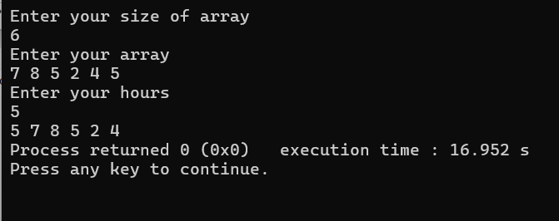
Problem 2:
I first thought of checking every book ID one by one, but that would take a lot of time for a large number of records. So, I used a HashMap to count how many times each book ID appears. Then, I printed only the IDs that appeared more than once.
Output:
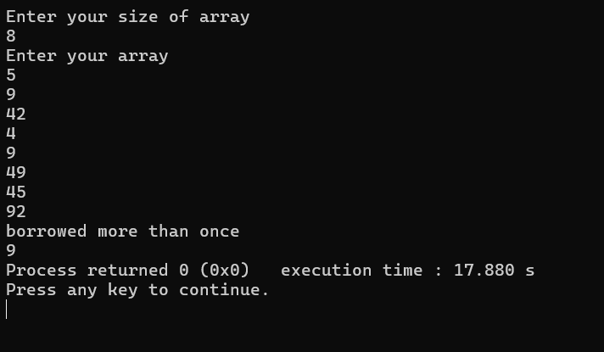
Problem 3:
I read the sentence and compared the length of each word. Whenever I found a longer word, I updated my answer. If two words had the same length, I kept the first one because I did not need to change it.
Output:
